Bugs reported

**1**.

**Bug Title*:***

Navigation link is broken

**Steps Action*:***

1. Main Page display – click on Popular Make: Lamborghini image
2. Click on ‘Buggy Rating’ link to go back to Main Page display

**Expected Result:**

Navigate back to the Main Page display

**Actual Result:**

Nothing happens, when you hover on the Buggy Rating link a url is displayed on the lower left corner -> https://buggy.justtestit.org/broken

**Screenshot:**

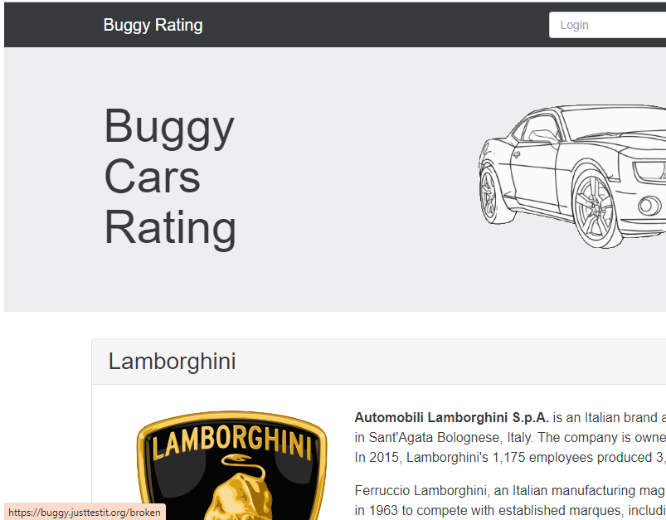

**What we do for this:**

To go back use the Back button of the browser you are using.

**2.**

**Bug Title:**

Broken Image link

**Steps Action**

1. Main Page – click Overall Rating Image link to navigate to Overall list page
2. Click filter : ‘Engine’
3. The list displays ‘Lancia Ypsilon’ as the first entry

**Expected Result:**

No broken link to any image

**Actual Result:**

The link to the image of the car ‘Lancia Ypsilon’ is broken

**Screenshot:**

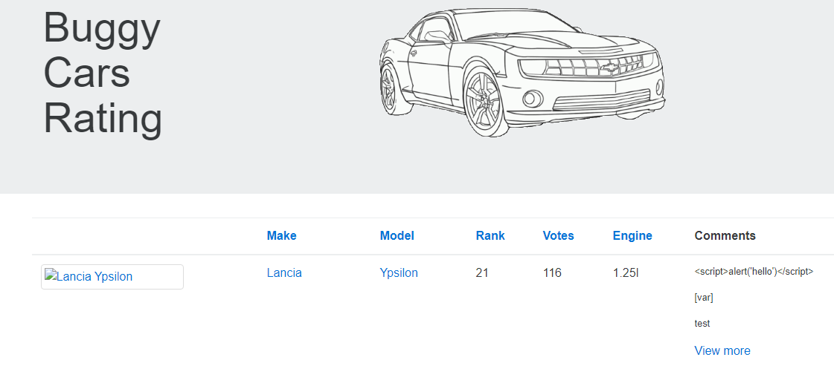

**What we do for this:**

None

**3.**

**Bug Title:**

Filter does not arrange entries properly

**Steps Action**

1. Main Page – click Overall Rating Image link to navigate to Overall list page
2. Click filter : ‘Rank’

**Expected Result:**

Rank should arrange entries from 1 to N entries

**Actual Result:**

Rank sort function is faulty. Rank goes from 1, 10, 11

***Screenshot:***

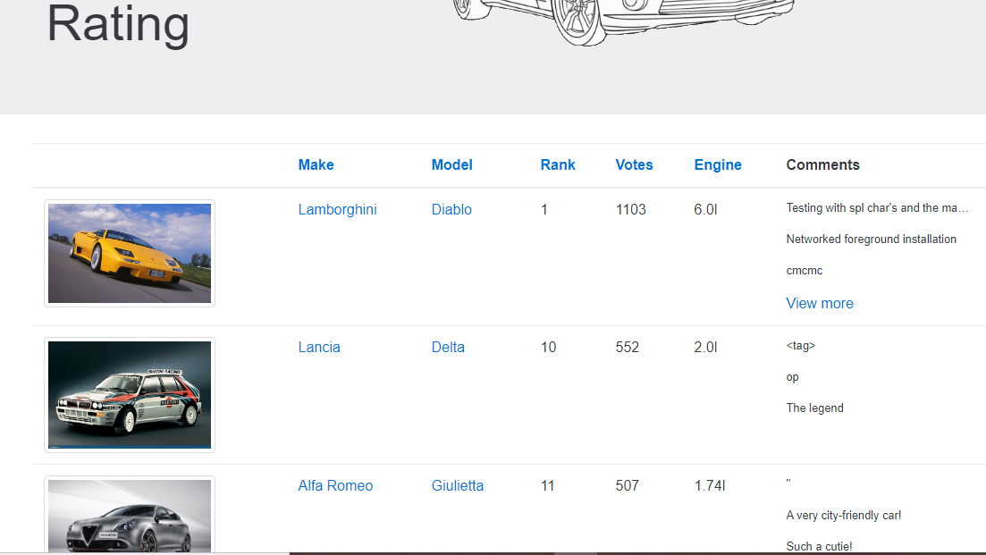

**What we do for this:**

None

4

**Bug Title:**

Votes link display next page

**Steps Action**

### Click on Lamborghini logo after login.

2 . Click on votes

**Expected Result:**

Link will not display next record; link will not work.

**Actual Result:**

By clicking on link displayed next records.

**Screenshot**

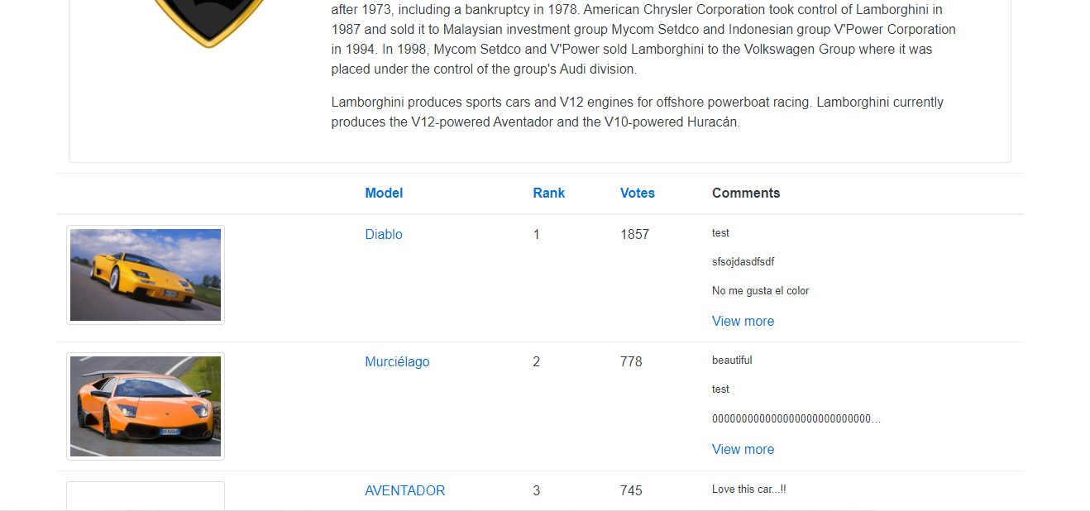

**What we do for this:**

None